**Soldering station**

|  |  |
| --- | --- |
| Author | Asadullah Chaudhry |

Content

1 Introduction 1

2 Material and methods 2

3 Results 2

3.1 Subtitle 1 2

3.1.1 Subtitle 2

3.1.2 Subtitle 2

3.2 Subtitle 2 2

3.2.1 Subtitle 2

3.2.2 Subtitle 2

4 Discussion 2

5 Reference list 2

# Introduction

[Describe your project:

* What did you build?
* What are the main characteristics of the device?
* What does it do?
* What is the reason you chose to build this device?
* What is your starting point? Are there any (scientifically-) related articles you used?
* Give an overview of the different topics you discuss in the Application Note.

Mind your writing style: do not write: “I had to do this for the course ‘Project Design.’ Instead use objective and informative sentences using the correct tense (Simple Present). Never use subjective expressions nor personal pronouns (I, we, you). Do not address the reader. Focus on the research: describe the situation and the process.

**+/- 100 words**]

The project is a soldering station with temperature regulation. This project allows progression in electronics. The soldering station has a few characteristics. Its temperature regulation ranges from 50°C to 450°C and it is also accurate. It uses a soldering tip which can be exchanged. The processor also continuously logs its data. The project idea and sources come from the magazine Elektor.

The schematic of the project’s PCB is also found in this magazine. This application note states the materials and methods used to build the station, a description of the end results and a discussion.

The application note is structured as follows. All the materials and methods that are used can be found/retrieved. This chapter also explains the purpose of each component.

# Material and methods

[Give an overview of the materials and the methods you used:

Materials: the components for the device

* Which materials (i.e. hardware and software) did you use and did you compare?
* Which materials were not useful and why not? Use proper, objective evaluation criteria.
* Add the Bill of Materials including an indication of the price, supplier name and delivery date (table in English!)

Methods: specific tools and procedures you use to collect and analyze data (for example, experiments, datasheets…)

* Include a schematic representation (i.e. flowdiagram) and explain this representation by providing a step by step overview of the design process, production process and testing process (including a description of the mechanical design).

**+/- 500 words**]

The project started on the computer. The PCB needed to be drawn and sent to a company, so they could create it. Altium Designer 21.1.1 is commonly used to draw the schematic and create the PCB. That’s why this software had to be used to draw the PCB.

The casing of the PCB was drawn in FUSION 360. This software was recommended for people who had close to no experience in 3D drawing. The case was partially printed on a 3D-printer and partially assembled form wood from using a laser cutter. The 3D printer and the laser cutter were both located at the PXL makerspace in Diepenbeek. Most of the components are supplied by Reichelt. This is a supplier that was recommended and used by many students from past years. One of the components that came from there was the RT soldering iron. There are a few input and output ports on the PCB. Two of them are connected with a terminal block. The other one has a micro-USB connection. The name of the manufacturer that the PCB was sent to is JLCPCB. This was recommended by the teacher. An alluminium shield was also ordered since the PCB had a lot of service mounted devices, like smd. This was used to apply soldering paste to the smd pads. The components were never compared to any others because they came straight from the magazine. The transistors were used as switches because the processor couldn’t handle high voltages. The used software and PCB manufacturer were recommended by the teachers. The suppliers weren’t easy to choose. Some could only be shipped in high quantities, while only one component was needed. Other suppliers had high shipping costs for a component that is less than 4 euros.

## 2.1 Bill of Materials:

The total billing is around 75 euros. The resistors are available at school, so they are not ordered online.

## 2.2 Method:

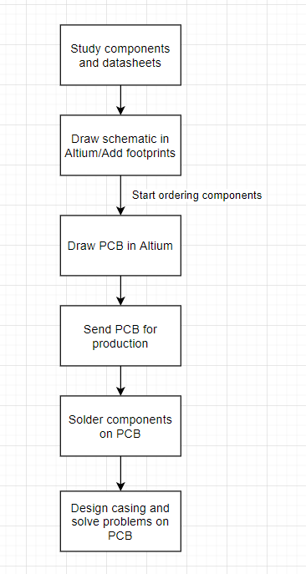

The first step in the building process is to study the components. Some specifications need to be learned before starting the project. Like if they are smd. This means that they need to be solder on the board. Or they can be through hole components. This means they have pins that go through the board and are soldered on the other side. Anything that might be useful to remember when drawing the schematic should be noted. The datasheets provide information about their components. Next is to draw the schematic in Elektor on Altium. Some components will not have a footprint. This need to be downloaded from the internet. At this point, the components must look to be ordered because the delivery can take long depending on the supplier. When the schematic is finished, the PCB needs to be made. While drawing the PCB, the distance between pads and tracks must be considered. Information on the minimum and maximum distance is found on the website of the manufacturer. After that the PCB needs to be produced by the manufacturer. It is best that the components arrive around this time. Because once the PCB arrives, the components need to be soldered on it. If there are any problems regarding the PCB or components they need to be solved now. Lastly, a casing needs to be drawn for the PCB to sit in. This is done in AutoCAD. It needs a unique logo that makes it stand out.

# Results

[Describe the end result you accomplished.

* Describe every aspect of your device. How does it function?
* Add an image of the electrical schematic, PCB design, finalized mechanical design, and finalized product

Write a well-structured text using subtitles and paragraphs.

**+/-500**]

## Subtitle 1

### Subtitle

### Subtitle

## Subtitle 2

### Subtitle

### Subtitle

# Discussion

[Reflect on and discuss your project.

* Which difficulties did you encounter during the design process and why? How did you solve these issues?
* Reflect on the process: did things go as expected? Would you choose the same approach if you had to do the project all over again? Are there issues that still need to be fixed? How come?

**+/-300 words**]

# Reference list

[Insert your reference list here.]